The Steppes “Activities” - February 2017
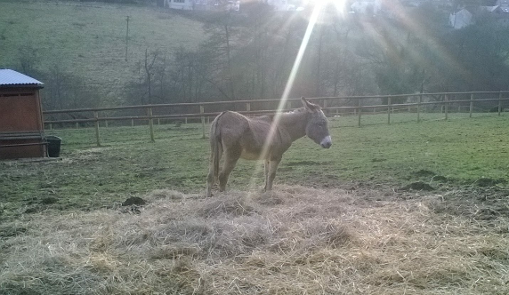
Nailsworth Donkey Sanctuary
Hello everyone, firstly could I say thanks to all those who joined us on a lovely “Burns Night” which was made even more special by some traditional bagpipe playing. Thank you, Graham. On a personal note I was delighted to taste my first haggis…and it’s a pity I’ll have to wait a whole year before my next. (photos from “Burns Night” and the visit from the “Zoo Lab” animals are on the notice boards. Copies are available from Nic)
This month can I draw your attention to a few events that may interest you. Firstly, on the 13th we have booked a group session at the nearby Arts and Crafts shop for those budding artists, then an extremely talented pianist will be visiting on 16th February and he will entertain you with some classics and maybe the odd romantic melody. The lovely donkeys from the local sanctuary are visiting on the 19th. On 28th February, by popular request, you are invited out for lunch at “The Old Nelson” pub in Stroud. Afterwards we will take a look around Stratford Park with it’s lake and wildlife. But remember to leave some room for a couple of pancakes for when we get home. Yes, the 28th is Shrove Tuesday and Sue cooks the best pancakes.
We will of course have the usual favourites such as “An Afternoon at the Races”, the weekly quiz, Friday afternoons at the pub and a couple of games of bingo. G fitness will be coming in to do an exercise session during the middle of the month and we have a couple of shopping trips planned.
Also, remember if you would like to borrow one of our iPads, at any time, please don’t hesitate to ask. Alternatively, Nic will be bringing them around with the shopping trolley on Tuesday’s and Friday’s.
We hope you all have a lovely month.
Best Wishes, Nic, Kim and Lorraine x
Dates for your Diary
>Tuesday, 7th February, 2pm – Shopping and coffee at Waitrose
>Monday, 13th February, 2pm – Arts and Crafts session
>Tuesday, 14th February – St Valentine’s Day
>Wednesday, 15th February, 11am – Exercises with G-Fitness
> Thursday, 16th February, 2pm – Kieran the pianist
> Sunday, 19th February, 3pm – A visit from 2 donkeys from Nailsworth Donkey Sanctuary
> Monday, 20th February, 2pm – Local shopping with Kim
> Friday, 24th February, 11.30m – Residents Meeting
> Tuesday, 28th February, Lunch out at the Old Nelson/Shrove Tuesday

Please complete and return to Nic at the end of the month if there are any trips out/activities you would like to see organised? ……………………………………………………………………………..…

