The Steppes “Activities” - January 2017
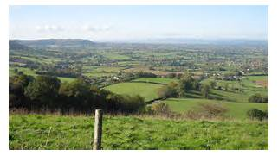
Coaley Peak
Hello everyone, welcome to 2017, hopefully it will be another good year. We (the activities coordinators) will endeavour to continue to keep you busy with activities full of joy and laughter; activities that are challenging, and activities that include new experiences as well as previously enjoyed ones.
We hope you have all had a lovely Christmas and enjoyed all the activities during December. We took lots of photos of all the events including the Staff Nativity (cameo appearances from Chris and Matilda) and the Pantomime by “Cats Pyjamas”. Nic will be sticking all these into a scrap book which he will bring around for you to see. If you would like a copy of any of them just let him know.

Some of the fun things we have planned for you this month include, a visit from the reptiles at Zoo Lab, a shopping trip to Waitrose and a trip to Coaley Peak viewpoint. We also have a couple of movie afternoons, the popular “Afternoon at the Races” and of course the usual midweek quiz with Lorraine, as well as pub games and bingo.

This month’s themed supper evening will be a “Burns Night” – but with absolutely no tears. Just traditional food (haggis, neeps and tatties) verse, music….and the odd dram.

We hope you all have a lovely month.
Best Wishes, Nic, Kim and Lorraine x

Dates for your Diary
>Tuesday, 3rd January. 2pm – Shopping and coffee at Waitrose
> Tuesday, 17th January. 3pm – Zoo lab
>Wednesday, 18th January, 11am – Exercises with G-Fitness
> Friday, 27th January. 11.30am - Residents meeting
> Friday, 27th January. 5pm – “Burns Night” supper evening
> Tuesday, 31st January, 2pm – “Afternoon at the Races”
> T.B.C – Trip to Coaley Peak viewpoint

Your Comments
Are there any trips out you would like to see organised? ……………………………

