The Steppes Newsletter – May 2017
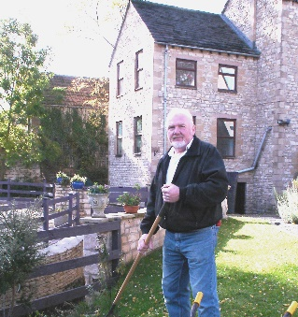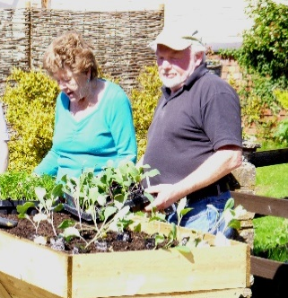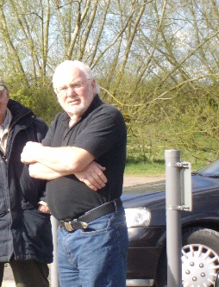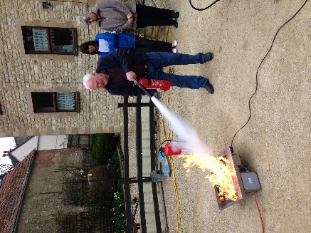
Our News
It’s a day we’ve all been dreading, but it was bound to happen one day… Richard is retiring. He has been a stalwart at The Steppes for 15 years and there aren’t adequate superlatives. He will be greatly missed. The good news is he’s still going to be around until July and also we have already found an able replacement, Steve. You have probably already met Steve, as he is now working alongside Richard and will continue to do so until Richard leaves. Other than the departure of Richard, I am very happy to say there are no other changes to our amazing staff.
On 8th June there will be a General Election and I’m sure the majority of you are intending to cast your vote. If you have any concerns about voting, please speak to Jo and she will be able to help. We can also help you getting to the polling station on Election Day, if required. It’s only 150 yards away in the local library and there’s a coffee shop opposite. Best Wishes, Julian

Activities
A massive “THANK YOU” to the “Mindsong Choir” who visited us last week. The whole choir were warm and friendly and everyone was encouraged to sing along. One resident said it was the best activity they had participated in during his time at The Steppes. If you missed it last time, great news, they have agreed to come again soon.
We would like to draw your attention to a few events that may interest you. Firstly, we have a trip on 9th May to Bristol Zoo. The weather forecast looks promising and I’m positive it will be dryer than the last visit. It rained meerkats and dogs! On the 16th May, it’s this years first gardening club so why don’t you join Richard and Steve for a bit of planting. Green fingers are optional. Later in the month we will be taking residents to Fromebridge Mill for lunch. This is a picturesque, old cider mill on the side of the River Frome.
We will of course have the usual favourites such as the weekly quiz, Friday afternoons at the pub and a couple of games of bingo. The morning exercise sessions continue and we have G-Fitness coming in again on the 11th May.
Also, remember if you would like to borrow one of our iPads, at any time, please don’t hesitate to ask. Alternatively, Nic will be bringing them around with the shopping trolley on Tuesday’s and Friday’s.
We hope you all have a lovely month. Best Wishes, Nic, Kim and Lorraine

Dates for your Diary NEWSFLASH
>Bank Holidays- Monday 1st May and Monday 29th May MINDSONG CHOIR
>Friday, 28th April, 11.30am – Residents Meeting BACK ON 11th MAY

Please complete and return to Nic at the end of the month if there are any trips out/activities you would like to see organised? ……………………………………………………………………………..…

