The Steppes Newsletter - April 2017
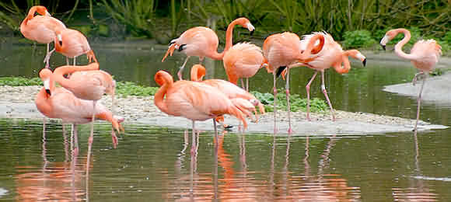
WWT Slimbridge Wetland Centre
Our News
Firstly, from all at The Steppes, can I take this opportunity to welcome our new residents. We will, as always, endeavour to make your stay, a happy stay.
Staffing- Congratulations to Mandy and Sandra who have recently completed their Diplomas In Care Level 2. There has been little change in the last 6 months regarding staff, the only small change is the employment of Karen, to occasionally help, with cooking/caring. Most will have already met Karen as she is very sociable.
We have a few small projects planned regarding the building. The first which commenced last week is the renovation of the laundry area. Hopefully this will cause little disruption and give us a nice, fresh, new place for laundry. The future projects involve redecoration of some communal areas and improvements in the kitchen. We will keep you informed of how these are developing.
Activities
I’m glad to hear the Chinese Supper Evening was a success. The aromas around the home were mouth-watering and making me feel very hungry. The next dinner party is on the 28th April. Let us know what theme (favourite food) you would like for this party.
Now with the improving weather, we would like to draw your attention to a few events that may interest you. Firstly, we have two visits out to Saul Junction. This involves a lovely canal boat trip (with wheelchair access and toilets) down the Gloucester and Sharpness Canal and of course a delicious picnic. There will also be a trip to the nearby, Slimbridge Wetland Centre, which is full of amazing wildlife (see picture above). This time of the year is especially exciting with the ducklings, goslings and cygnets.
We will of course have the usual favourites such as the weekly quiz, Friday afternoons at the pub and a couple of games of bingo. The morning exercise sessions continue (followed by Gong relaxation on 6th April) and we have a movie matinee planned with popcorn and drinks.
Also, remember if you would like to borrow one of our iPads, at any time, please don’t hesitate to ask. Alternatively, Nic will be bringing them around with the shopping trolley on Tuesday’s and Friday’s.
We hope you all have a lovely month. Best Wishes, Nic, Kim and Lorraine

Dates for your Diary
>Saturday, 15th April, 5.15pm – Grand National
>Easter Sunday, 16th April, 2pm
>Friday, 28th April, 11.30am – Residents Meeting, 5pm – Dinner Party

Please complete and return to Nic at the end of the month if there are any trips out/activities you would like to see organised? ……………………………………………………………………………..…

